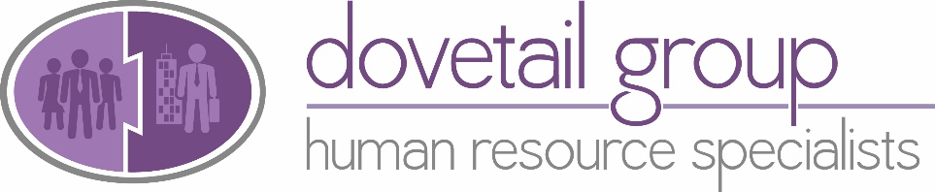 

INTERVIEW TIPS

*Got an interview coming up? How do they make you feel? A job interview is one of those life events that regrettably never gets any less daunting, but preparation is key and essentially you need to sell yourself and leave a great first impression.*

*Some of this handy checklist will be common sense but perhaps some points will help you think outside the box and get the very best out of your interview.*

1. **1).** **Research the industry, company and individual you are being interviewed by**

Read company reviews to learn more about the company culture and what others are saying about this employer. LinkedIn is a great tool for researching the interviewer.

Be prepared that you may be asked how you perceive this company's position within the industry, who the firm's competitors are, what its competitive advantages are, and how it should best go forward.

1. **2). Re read the job description and clarify your "selling points" and the reasons you want the job**

Prepare to go into every interview with three to five key selling points in mind, such as what makes you the best candidate for the position.

**3). Anticipate the interviewer's concerns and reservations**

There are always more candidates for positions than there are openings, so interviewers look for ways to screen people out. Put yourself in their shoes and ask yourself why they might not want to hire you.

**4). Prepare some questions for the interviewer**

Come to the interview with some intelligent questions for the interviewer that demonstrate your knowledge of the company as well as your serious intent.

**5). Dress for the job you want**

If you’re speaking to a recruiter before the interview, you can ask them about the dress code in the workplace and choose your outfit accordingly.

**6). Don’t be late (or too early!)**

Plan your schedule so that you can arrive 10 minutes early. Map out your route to the interview location so you can be sure to arrive on time. Consider doing a trial run. If you’re taking public transportation, identify a backup plan if there are delays or closures. If you arrive earlier than 10minutes prior to your interview take a walk or have a quiet coffee somewhere to collect yourself.

**7). Treat every single person you encounter with respect**

This includes people on the road and in the parking lot, security personnel and front desk staff. Treat everyone you don’t know as though they’re the hiring manager.

# 8). Respond truthfully to the questions you are asked

# Tie your answers back to your skills and accomplishments by providing examples of solutions and results you’ve achieved.

**9). Answer the question you’re being asked not the one you think you’re being asked**

Don’t be afraid to ask the interviewer to expand on a question if you’re not sure what they’re asking.

**10). Ensure you bring a copy of your CV to every interview for reference**

If you have been put forward by a recruitment agency they may have made a few adjustments so ensure you have the same copy that the interviewer does.

**11). Use confident, accessible body language**

Smile frequently. Make eye contact when you’re speaking. Sit or stand tall with your shoulders back. Before the interview, take a deep breath and exhale slowly. This will help you manage any feelings of anxiety and will encourage greater self-confidence.

**12). Be prepared for different styles of interviews**

Competency Vs Behavioral, Panel Vs Single interviewer etc.

**13). Manage time expectations**

Ascertain before the interview the potential length and ensure that parking tickets etc. won’t run out. If you need to be back at work be open when the interview is first arranged and state that you’ll need to leave by a certain time.

**14). Close on a positive note and if appropriate send a thank you email/note to clarify why you think you’d be perfect for the role**

Personalise your notes by referring specifically to what you and the interviewer discussed and reiterate your interest in the company and the position.

**15). Connect with the interviewer on LinkedIn if appropriate**

With social media being welcomed increasingly into the professional domain, it’s sometimes appropriate to ask your interviewer to connect with you on LinkedIn in the days following the meeting. While it shouldn’t replace the standard thank you email, this is a great way to jog a potential employer’s memory and to remind them that you exist. Even if you don’t end up getting the job, it could potentially lead to a fruitful professional relationship.

**16). Don’t give up!!**

Learn from each interview experience and take on feedback whether good or bad.

For further information on how we can help you secure your perfect job email hello@dovetailhrs.co.uk or call **01635 43100**